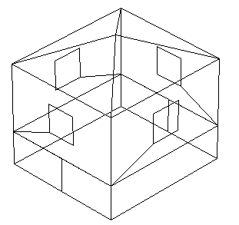
Exterior boundary condition
BASESIMP boundary condition

Break the side basement walls in two – with the back sections having BASESIMP boundary conditions and the front sections having EXTERIOR boundary conditions.

The front basement wall has an EXTERIOR boundary condition.

The front basement wall has a BASESIMP boundary condition.

